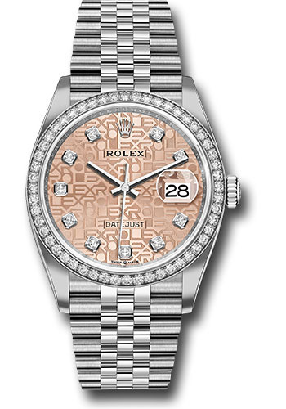

**Danny yoo**

2215 cedar spring rd apt 204

Dallas texas

**Manufacturer:** Rolex

**Model Name:** Datejust 36

**Factory Model:** 126284RBR

**Serial No.:** U102U288

**Size:** 36mm

**Dial:** Pink Jubilee Diamond Dial

**Bezel:** Diamond Bezel

**Metal:** Stainless Steel

**Bracelet Material:** Stainless Steel

**Crystal:** Sapphire

**Features**

Any questions regarding this appraisal can be sent to myluxapp.com via email at hello@myluxapp.com or can be mailed to:

myluxapp.com 650 S. Hill St. Suite 317 Los Angeles, CA 9001

213-985-3753

**$19,162.50**

**Suggested Appraised Value* :**

**Appraised For**

*myluxapp.com is a registered DBA of Shak Corp Inc. This is not an invoice or receipt of sale. Suggested MSRP/Appraised Value is calculated based on estimated market prices for this item sold in other retail stores at the time of appraisal. myluxapp.com provides appraisal and other related services for Watches, Jewelry, Diamonds and Gold. myluxapp.com is a not affiliated with any of the brands of watches, jewelry, diamonds and/or gold that have been appraised in this report, unless specified otherwise. The values set forth herein are estimates of the current market price at which the appraised jewelry may be purchased in the average fine jewelry store at the time of appraisal. Because jewelry appraisal and evaluation is subjective, estimates of replacement value may vary from one appraiser to another and such a variance does not necessarily constitute error on part of the appraiser. This appraisal should not be used as the basis for the purchase or sale of the items set forth herein and is provided, solely as an estimate of approximate replacement values of said items at this time and place. Accordingly, we assume no liability with respect to any legal action that may be taken, as a result of, the information contained in this appraisal.

**Details of Appraisal**

Appraisal Number: **915000122051**

Appraisal Location: **Los Angeles, CA 90014 Appraisal**

Date: **12/02/2020**

**Image**

**Appraisal Report**

The following appraisal service report identifies the characteristics of the referenced watch at the time of inspection. This appraisal report establishes the new retail replacement value in the most common and appropriate jewelry markets, to provide a basis for obtaining insurance.

Inspected/Appraised by Myluxapp.com

